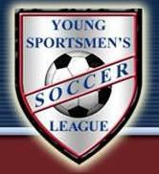
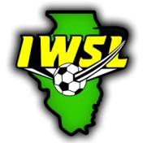
YOUNG SPORTMEN’S SOCCER LEAGUE
ILLINOIS WOMEN’S SOCCER LEAGUE
P.O. BOX 68849, Schaumburg, IL 60168 847-985-4975
www.iwsl.com
P.O. BOX 724, Arlington Heights, IL 60006 847-818-1440
www.yssl.org

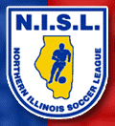
NORTHERN ILLINOIS SOCCER LEAGUE
545 Consumers Ave, Palatine, IL 60074
847-398-4545
www.nisl.info

PLAYER REGISTRATION FORM – Soccer Year 2017-2018

NEW PLAYER
RETURNING PLAYER (Check One)

CLUB/TEAM NAME: PALATINE CELTIC SOCCER CLUB TEAM U-AGE:

PLAYER’S FIRST NAME:
LAST NAME:

PLAYER’S ADDRESS: ____________________________________________________________________________

CITY: _ STATE: ZIP:

PLAYER CELL PHONE: PLAYER EMAIL:

PLAYER BIRTHDATE:

FATHER’S NAME: HOME PHONE: ______________CELL PHONE:

FATHER’S EMAIL: _________________________________

MOTHER’S NAME: HOME PHONE: ______________CELL PHONE:

MOTHER’S EMAIL: ________________________________

PROOF OF AGE REQUIRED FOR NEW PLAYERS ONLY TO LEAGUE

Government Issued Birth Certificate Passport

I understand that by signing this document I (or my child) have not registered with any other IYSA or US Club Soccer registered team for the above indicated playing year and is committed to playing for only this team until an applicable release for another team or club is obtained and submitted per league rules. For IWSL players only - I am aware that IWSL league rules only permit transfers to other clubs during or after the month of January.

PLAYER’S SIGNATURE: DATE:

PARENT’S SIGNATURE: DATE:

CLUB/COACH SIGNATURE: DATE:

This form must be kept on file by the Club for the entire playing year indicated

